LAMP LIFE EXTENDER BY ZVS (Zero Voltage Switching)

ABSTRACT

The project is designed to develop a device to increase the life of incandescent lamps. Incandescent lamps exhibit very low resistance in cold condition due to which it draws high current while switched ON, resulting in fast failure.
Random switching of lamps may switch the load at peak supply voltage. When such switching occurs while the lamp is having low resistance (cold condition) then the current further shoots up (at the time of peak supply voltage switch ON) leading to premature failure of the lamp. The proposed project provides a solution by engaging a TRIAC in such a way that the switch ON time is precisely controlled by exactly firing it after detecting the zero cross point of the waveform of supply voltage. This would result in current waveform rising from zero at the time of switch to full value, thereby increasing the life of the lamp. The project is having comparator which is used for ZVS output. The ZVS (zero voltage switching) is given as reference interrupt to the microcontroller of PIC family. A push button is used for switching ON the lamp at zero voltage of the supply voltage so the lamp draws current gradually from zero to full value.
Further the project can be enhanced by using three TRIACS, one in each phase for three phase load switching.

BLOCK DIAGRAM:

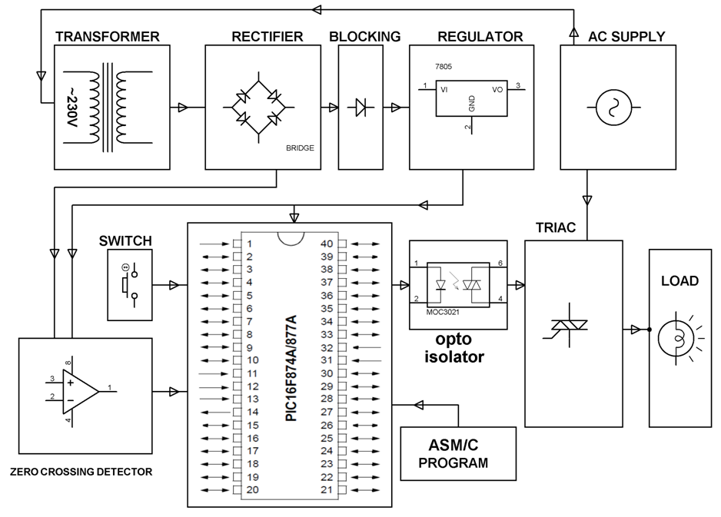

HARDWARE REQUIREMENTS:

PIC series Microcontroller, OPAMP, Opto-Isolators, TRIAC, Transformer, Diodes, Voltage Regulator, Push Button, LED, Resistors, Capacitors, Crystal, Load.

SOFTWARE REQUIREMENTS:

HI-TECH PICC Tool suite
Languages: Embedded C or Assembly

